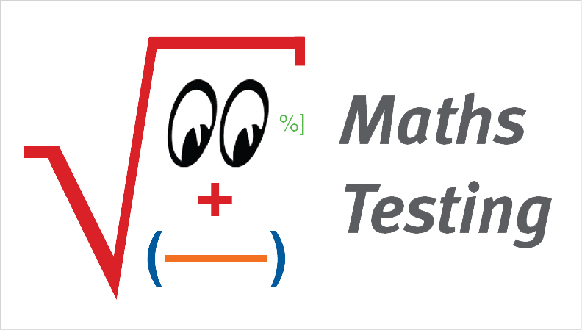

_____________________________________

**(Print your name)**

**Recruitment Test - REC#03**

**Allotted Time: 60 minutes**

**Please read the following very carefully before starting the test.**

1. Print your name at the top of this page.
2. Answer **all** questions and do not use any red ink.
3. Do not write **beyond the bar** on the right-hand side of the test pages.
4. Do not remove the staples; if you need more space for calculations or notes, use the back of the preceding page.
5. Please note that a **comma** is used as the **decimal separator** in all decimal numbers and a point is used as the thousands separators.
6. For the correct answer you will receive the number of points shown in parentheses to the right of each question; we chose the number of points that can be earned based on the approximate amount of time you should need to solve each question.

NO CALCULATORS NO MOBILE PHONES NO BOOKS OR NOTES

|  |  |  |  |  |  |  |
| --- | --- | --- | --- | --- | --- | --- |
| **Page #** | **2** | **3** | **4** | **5** | **6** | **Total** |
| **Questions** | 1 - 3 | 4 -6 | 7 - 9 | 10 - 13 | 14 - 15 | **1 - 15** |
| **Max. no. of points** | 13 | 12 | 13 | 14 | 8 | **60** |
| **Points received** |  |  |  |  |  |  |

1. The graph below shows a pyramid. **Fill** in each circle with a **different digit** from 0 to 9 such that the sum of all three sides will have the same value. [8.69]  
    **(4 pts. for the correct answer = 4 points)**

Don’t write beyond this line. We need space for marking!



1. When Anna was asked how old she is, she answered: “Multiply my age by 99, add 208 to this product and subtract 99. The result will be exactly 1000.” **How old** is Anna? [6.34]  
    **(3 pts. for the correct answer = 3 points)**
2. Transform the decimals into **fractions, cancelling** out all common factors. [1.7]  
    **(2 pts. for each correct answer = 6 points)**
3. 2,75 =
4. 0,85 =
5. 0,0075 =

____________________________

Total points earned on **this page #2**

1. Calculate the **value** of the expression. [3.18]  
    **(3 pts. for the correct answer = 3 points)**

Don’t write beyond this line. We need space for marking!



1. Each lineshouldcontain the given value in different forms. **Complete** the missing decimals, fractions and percentages in the shaded cells. [1.19]  
    **(1 pt. for each correct answer = 6 points)**

|  |  |  |
| --- | --- | --- |
| **Decimal form** | **Fraction form** | **Percentage form** |
| 0,007 |  |  |
|  |  |  |
|  |  | 125% |

1. Cancel all common factors in the **fractions**. [2.3]  
    **(1 pt. for each correct answer = 3 points)**

a) 

b) 

c) 

____________________________

Total points earned on **this page #3**

1. **Continue** the sequence of letters logically. [8.74]  
    **(1 pt. for each correct answer = 4 points)**

Don’t write beyond this line. We need space for marking!

1. A – X – Y – D – X – Y – G – X – Y **–** **___**
2. N – K – H – E – **___**
3. A – B – B – C – D – D – E – F **–** **___**
4. D – V – C – W – B – X **– ___**
5. Decide which of the four flags in the lower row must replace the question mark. **Tick** the corresponding position. [8.70]  
    **(3 pts. for the correct answer = 3 points)**



1. What is the relation of the four expressions? Order the four by value in decreasing sequence (as for instance ***A*** > ***B*** > ***C*** > ***D***). [3.19]  
    **(3 pts. for each correct answer = 6 points)**
2.  ;  ; *C =;* → *___* > ___ > ___ > ___
3.  ;  ; *;* → *___* > ___ > ___ > ___

____________________________

Total points earned on **this page #4**

1. Calculate **the values** corresponding to the given percentages. [4.54]  
    **(2 pts. for each correct answer = 4 points)**

Don’t write beyond this line. We need space for marking!

1. 2% of 4,5 million people →
2. 12% over the allowed speed of 80 km/h →
3. One side of a rectangle is reduced by 20% and the other side is increased by 20%. Calculate the **percentage change** of the area of this rectangle. [4.21]  
    **(3 pts. for the correct answer = 3 points)**
4. The inner dimensions of a bin are: Length = 80cm; Width = 40cm; Height = 60cm. How many litres of water can the bin hold (1 litre = 1 dm3 = 1000cm3) [13.8]?  
    **(3 pts. for the correct answer = 3 points)**



1. You have 17 litres of gasoline left in the tank of your car and the display says that you can drive another 240 km. The capacity of your tank is 51 litres. **What is the maximum distance you can** drive the car at the same average speed if you fill up the tank? [9.9]  
    **(4 pts. for the correct answer = 4 points)**

____________________________

Total points earned on **this page #5**

1. The numbers in the following **table** were filled in according to a certain system. Complete the table by filling in the **shaded cells**. [8.75]  
    **(2 pts. for each correct answer = 4 points)**

Don’t write beyond this line. We need space for marking!

|  |  |  |  |
| --- | --- | --- | --- |
|  | 3 | 2 | 1 |
| –1 | 2 | –3 | 2 |
| 5 | 5 | –1 |  |
| 25 | 25 | 1 | 9 |

1. **Find the number** which logically has to be on the empty card. [8.112]  
    **(4 pts. for the correct answer = 4 points)**



____________________________

Total points earned on **this page #6**