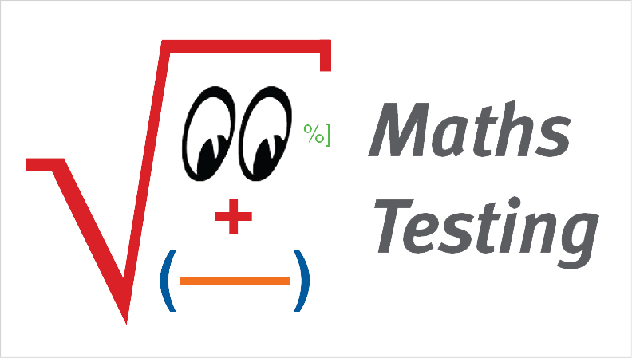

_____________________________________

**(Print your name)**

**Recruitment Test - REC#07**

**Allotted Time: 60 minutes**

**Please read the following very carefully before starting the test.**

1. Print your name at the top of this page.
2. Answer **all** questions and do not use any red ink.
3. Do not write **beyond the vertical line** on the right-hand side of the test pages.
4. Do not remove the staples; if you need more space for calculations or notes, use the back of the preceding page.
5. Please note that a **comma** is used as the **decimal separator** in all decimal numbers and a point is used as the thousands separators.
6. For the correct answer you will receive the number of points shown in parentheses to the right of each question; we chose the number of points that can be earned based on the approximate amount of time you should need to solve each question.

NO CALCULATORS NO MOBILE PHONES NO BOOKS OR NOTES

|  |  |  |  |  |  |  |
| --- | --- | --- | --- | --- | --- | --- |
| **Page #** | **2** | **3** | **4** | **5** | **6** | **Total** |
| **Questions** | 1 - 3 | 4 -6 | 7 - 9 | 10 - 12 | 13 - 15 | **1 - 15** |
| **Max. no. of points** | 13 | 9 | 14 | 13 | 11 | **60** |
| **Points received** |  |  |  |  |  |  |

1. Each lineshouldcontain the given value in different forms. **Complete** the missing decimals, fractions and percentages such that the values in each line are identical. [1.6]  
    **(1 pt. for each correct answer = 5 points)**

Don’t write beyond this line. We need space for marking!

|  |  |  |
| --- | --- | --- |
| **Decimal form** | **Fraction form** | **Percentage form** |
|  |  | 72% |
| 0,003 |  | 0,3% |
| 1,34 |  |  |

1. Transform into **percentages**. [1.13]  
    **(2 pts. for each correct answer = 4 points)**
2.  =
3. 0,02×0,02 **=** 0,0004 **=**
4. **Insert the numbers from 1 to 9** in the figure below such that no number is repeated and the sum of each of the four lines is 15. (There are various possibilities.) [8.58]  
    **(4 pts. for the correct answer = 4 points)**



____________________________

Total points earned on **this page #2**

1. **Transform** the following expressions into fractions (common factors do not need to be cancelled). [1.21]  
    **(1 pt. for each correct answer = 3 points)**

Don’t write beyond this line. We need space for marking!

1. 1,016 =
2.  =
3. 12×5% **=**
4. Lamp A is darker than lamp B. Lamp B is brighter than C. C is as bright as D. B is brighter than D. D is brighter than A. **Which lamp is the brightest**? [8.79]  
    **(3 pts. for the correct answer = 3 points)**
5. Calculate the **value** of the following expression. [3.3]  
    **(3 pts. for the correct answer = 3 points)**



____________________________

Total points earned on **this page #3**

1. The numbers in the following tables were filled in according to a certain system. Complete the tables by filling in the **empty cells**. [8.19]  
    **(2 pts. for each correct answer = 4 points)**

Don’t write beyond this line. We need space for marking!

|  |  |  |  |
| --- | --- | --- | --- |
| a) | 7 | 10 | 3 |
|  | 4 | 7 |  |
|  | 1 | 4 | –3 |

|  |  |  |  |
| --- | --- | --- | --- |
| b) | 3 | 9 | 27 |
|  | –2 | 4 | –8 |
|  | 1 | 1 |  |

1. A mobile phone costs 108 EUR; 20% VAT is included in the price. [4.8]  
    **(2 pts. for each correct answer = 6 points)**
2. What is the **net price**?
3. VAT is going to be increased to 22%. What will the **new sales price** be?
4. In order to become competitive, the seller decreases the net price by 10%. What is the **new sales price** (with 22% VAT)?
5. Every morning Peter rides his bicycle from his house to the office. He rides at an average speed of 12 km/h (kilometres per hour) and needs 35 minutes for the commute. What is **the distance** from his house to the office **in km**? [6.32]  
    **(4 pts. for the correct answer = 4 points)**

____________________________

Total points earned on **this page #4**

1. Calculate the **value** of the expressions. [3.8]  
    **(3 pts. for each correct answer = 6 points)**

Don’t write beyond this line. We need space for marking!

1. 
2. 
3. According to the logic of the table, which number belongs in the shaded cell? [8.82]  
    **(3 pts. for the correct answer = 3 points)**



1. The last time you refuelled your car, you realised that you needed 45,5 litres of gasoline to travel 650 km. [9.4]
2. **How much gasoline** did you use on average for 100 km?
3. This time you filled your tank up and it now contains 66,5 litres. **How far** can you drive assuming that you drive at the average speed stated in question a)?   
    **(2 pts. for each correct answer = 4 points)**

____________________________

Total points earned on **this page #5**

1. The weather report frequently measures the amount of rainfall in a certain time period in millimetres. **How many litres** per square metre are 50 mm of rain? [13.5]  
    **(4 pts. for the correct answer = 4 points)**

Don’t write beyond this line. We need space for marking!

1. In two years from now Anna will be half as old as her mother was two years ago. However, today her mother is four times as old as Anna was 10 years ago. **How old** are Anna and her mother, respectively? [6.1]  
    **(4 pts. for the correct answer = 4 points)**
2. How many of the three dice can be folded from the original pattern? [8.109]  
    **(31 pt. for each correct answer = 3 points)**



____________________________

Total points earned on **this page #6**